Mohamed Ahmed Mohamed Abd-Elgani
Lab-4
========================================

1.List the user commands and redirect the output to /tmp/commands.list
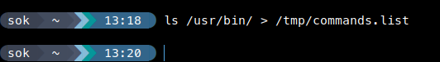

2. Count the number of user commands

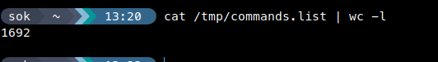

3. Get all the users names whose first character in their login is ‘g’.

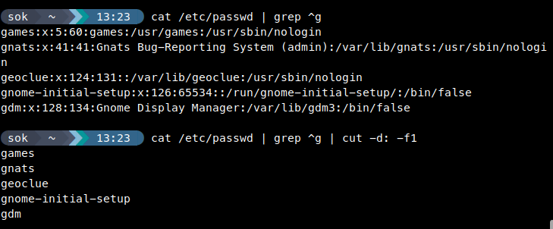
4. Get the logins name and full names (comment) of logins starts with “g”.


5. Save the output of the last command sorted by their full names in a file.
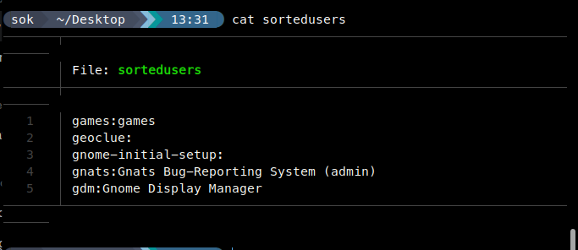
6. Write two commands: first: to search for all files on the system that named
.bash_profile. Second: sorts the output of ls command on / recursively, Saving
a-

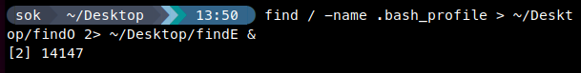
b-

7. Display the number of users who is logged now to the system.

8. Display lines 7 to line 10 of /etc/passwd file


9. What happens if you execute:

• -cat filename1 | cat filename2
cat the secound file
• -ls | rm
Delets the files listed by ls + dirs if -r
• -ls /etc/passwd | wc –l

count the lines in the output from the ls etc/passwod

10.Issue the command sleep 100.
11.Stop the last command.

Ctrl + z
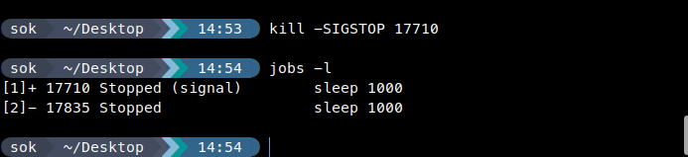

12.Resume the last command in the background

12.Resume the last command in the background
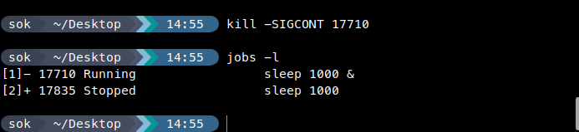

13.Issue the jobs command and see its output.

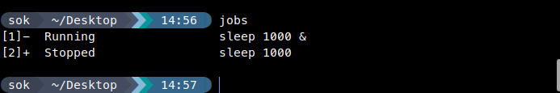
14.Send the sleep command to the foreground and send it again to the background.
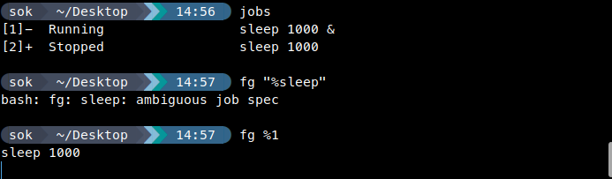
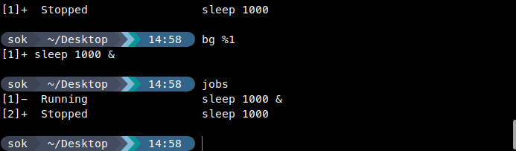

15.Kill the sleep command.

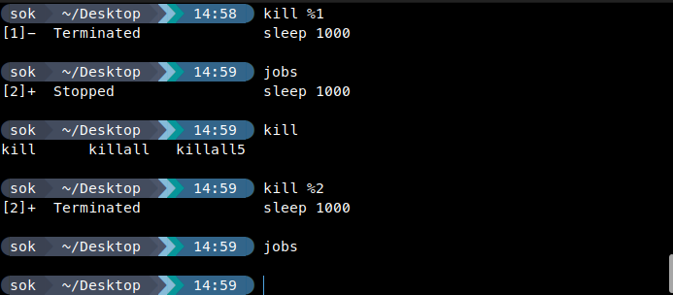

16.Display your processes only

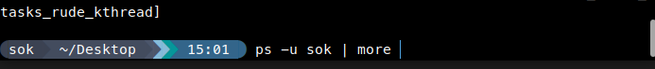
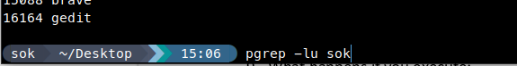

17.Display all processes except yours

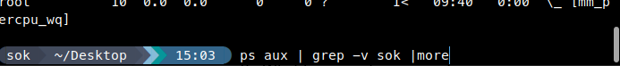
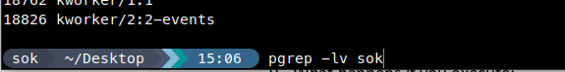

18.Use the pgrep command to list your processes only

19.Kill your processes only.
Pkill -u name

